Fact Sheet for School Leaders
Career Technical Education
Supports Successful Local Control Accountability Plan Implementation
--------------------------------
Career and College Transition Division/California Department of Education
1430 N Street, Sacramento, CA 95814 cte@cde.ca.gov 916-445-2652

Career technical education (CTE), is an important program that will help local educational agencies (LEA) meet new requirements outlined in Local Control Accountability Plans (LCAP).

Whether a school district or county office of education is considering maintaining an existing CTE program or starting a new one, administrators will find that CTE is a critical component of a broad and deep school curriculum that helps prepare all students to be career and college ready.

CTE practitioners and experts concur that the discipline provides relevance and real world content for academic studies while promoting teamwork and cooperative learning. It builds teacher, counselor, parent, business, and community engagement.

It also encourages students to see a high school diploma and readiness for college or other postsecondary study as a foundation for the future rather than as an end in and of itself.

http://www.cde.ca.gov/ci/ct/

CTE provides proven models for assisting LEAs in offering programs and curricula consistent with the following LCAP requirements:

- CONDITIONS OF LEARNING

Basic

- CTE provides students with real world 21st century skills that make them career and college ready.

- The State offers more than 10,000 CTE courses that meet a-g requirements necessary for entrance into the UC college system.

- CTE provides students with not only career and academic skills, but soft skills that are needed for the modern workplace, such as: critical thinking; communication; team work; citizenship, integrity, and ethical leadership; research tools; creativity; and innovation.

- CTE helps satisfy the California Education Code (Ed Code) language encouraging districts to provide all pupils with a rigorous academic curriculum that integrates academic and career skills, incorporates applied learning in all disciplines, and prepares all pupils for high school graduation and career entry.

State Standards Implementation

- CTE courses help LEAs comply with Ed Code requiring a course of study that provides an opportunity for those pupils to attain entry-level employment skills in business or industry upon graduation from high school.

- All CTE programs are prepared in line with CTE Model Curriculum Standards and newly instituted Common Core State Standards requirements.

Course Access

- CTE courses help school districts comply with education code requirements to prepare youth for gainful employment in the occupations and in the numbers that are appropriate to the personnel needs of the state and community served.

- CTE courses offer articulation agreements and dual enrollment options for schools to partner with local colleges so students have an early awareness that college is a possibility.

- CTE brings specialized instructors into class, and offers industry-specific courses so students get an intimate understanding of what it is like to work in that industry sector.

- CTE provides more creative opportunities for students to participate in online blended courses and modules focused on given industry sectors.

- PUPIL OUTCOMES

Pupil Achievement

- Students in California Partnership Academies (CPA) were much more likely than their high school peers to complete academic a-g courses needed for admission to California’s public colleges and universities—
57 percent to 36 percent.

- Attendance more than doubled the rate of college entrance for minority students and increased college enrollment rates for all student populations compared to local and state student populations.

- Students who complete a rigorous academic core coupled with a career concentration have test scores that equal or exceed “college prep” students; are more likely to pursue postsecondary education; have a higher grade point average (GPA) in college; and are less likely to drop out the first year of college.

- 80 percent of students taking a college prep academic curriculum with rigorous CTE met college and career readiness goals, compared to 63 percent of students who did not take CTE.

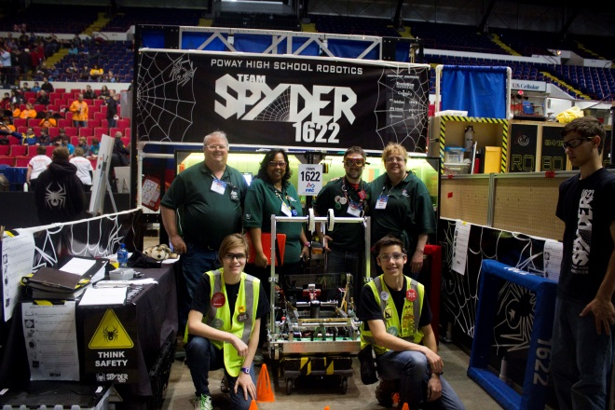

- Average national graduation rate in 2008 for students concentrating in CTE was 90 percent; other students, 75 percent.

- CPA students beat state averages in passing the California high school exit exam.

- CPA seniors graduate on time at a rate of 95 percent — 10 percent higher than the state average.

Other Pupil Outcomes

- 57 percent of CPA students met UC a-g requirements — 21 percent higher than non-CPA students.

- ENGAGEMENT

Parent Involvement

- Parents are an important part of each LEA’s CTE advisory committee and their active involvement is required per US Education Code.

- Each CPA must have an advisory committee made up of all stakeholder groups, including parents.

Pupil Engagement

- CTE increases engagement in school by involving students as decision-makers and “owners” of their education process.

- CTE significantly increases not only the high school graduation rate, but also results in a higher percentage of students going to college and persisting through graduation.

- Students taking both academic and technical courses have lower dropout rates and better achievement gains than other students.

- Students of Regional Occupational Centers and Programs were typically from lower achieving and lower socioeconomic status than peers, but were just as likely to enroll in postsecondary education and eventually earn higher wages.

- Students have a decreased risk of dropping out of high school as they add CTE courses to their curriculum.

- High-risk students are 8 to 10 times less likely to drop out in grades ten and eleven if they enroll in a CTE program instead of a general program.

- The National Dropout Prevention Center/Network states quality CTE and related guidance programs are “essential for all students” and coupled with other strategies have the most impact on the dropout rate.

School Climate

- CTE has been found to increase school connectedness, reduce behavioral problems related to suspensions and expulsions, and reduce dropout rates among all student groups — especially among students most at risk of dropping out.

College and Career Readiness and Success

CTE has also been proven to help students become college and career ready, as listed under the State Priorities in the ED Code. Specifically, CTE does the following:

Improves success in college

- More likely to go to college or postsecondary program — 79 percent go within two years

- Maintain a higher GPA

- More likely to stay in college

Improves success in work and life

- 95 percent of CTE students who did not go to college worked for pay within two years of high school graduation.

Increases Career Readiness

- Experts project 47 million job openings in the decade ending in 2018. About one-third will require an associate’s degree or certificate and nearly all will require real world skills that can be mastered through CTE.

_______________________________________________________

Professional State Leadership in CTE

The California Department of Education provides education program consultants who cover the 15 Industry Sectors, as well as the California Partnership Academies, Linked Learning Program, Regional Occupational Centers and Programs, and California Career Pathways Trust Grant Program.

For help in preparing your LCAP, or for more information about included statistics, program information, and research within this fact sheet, please feel free to contact us. We would be more than happy to help!

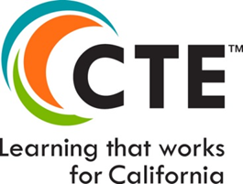
LCAP/LCFF Information:
Local Control Funding Office
http://www.cde.ca.gov/fg/aa/lc/
LCFF@cde.ca.gov
916-319-0809

CTE Program Information:
Career and College Transition Division
http://www.cde.ca.gov/ci/ct/
cte@cde.ca.gov
916-445-2652

